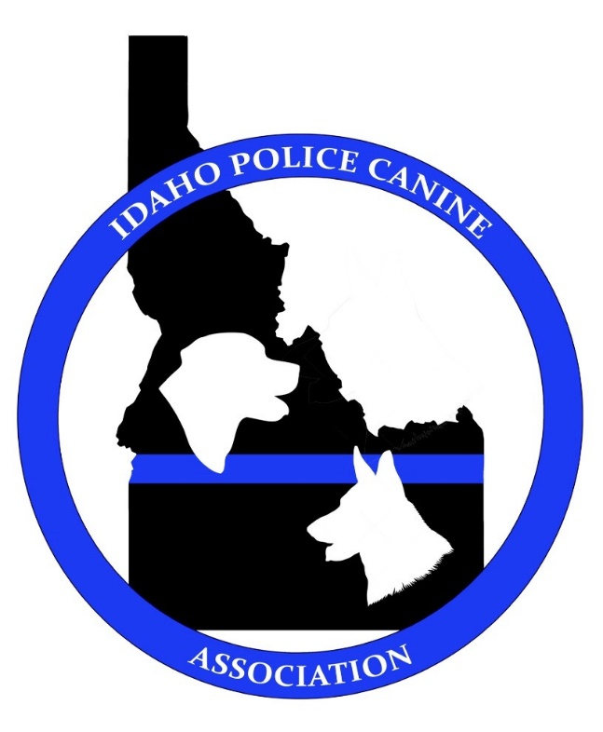
Idaho Police Canine Association Conference
May 2nd-6th 2022

Hosted by Treasure Valley Agencies
Boise, Idaho
- Registration $250 includes 1-year IPCA Membership
- 40 hour Working Conference (Patrol / Detection)
- Check in May 1st 1600-1900 hours (Hospitality Room)
- Banquet/Awards/Raffle - May 5th 1900 hours - Boise Police Club House
Host Hotel Information
TBD

Questions Contact:
Jason Piccola (Ada County Sheriff)
jpiccola@adacounty.id.gov

